i

# Architecture

Spam Ham Classifier

|  |  |
| --- | --- |
| Written By | Mohit Bhadauria |
| Document Version | 1.0 |
| Last Revised Date | 26-12-2022 |

01

Document Version Control

Change Record:

|  |  |  |  |
| --- | --- | --- | --- |
| Version | Date | Author | Comments |
| 1.0 | 26-11-2022 | Mohit  Bhadauria | Architecture |
|  |  |  |  |
|  |  |  |  |
|  |  |  |  |

Reviews:

|  |  |  |  |
| --- | --- | --- | --- |
| Version | Date | Reviewer | Comments |
|  |  |  |  |

Approval Status:

|  |  |  |  |  |
| --- | --- | --- | --- | --- |
| Version | Review Date | Reviewed By | Approved By | Comments |
|  |  |  |  |  |

02

## Contents

Document Version control 2

1. Architecture 4

1. Architecture Description 5
   1. Data Description 5
   2. Export Data from DB to CSV for training --------------------------------- 5
   3. Data Preprocessing 5
   4. Data Clustering 5
   5. Get best model of each cluster -------------------------------------------- 5
   6. Hyperparameter Tuning 5
   7. Model saving 6
   8. Cloud setup 6
   9. Push App to cloud 6
   10. Data from client side for prediction -------------------------------------- 6
   11. Export prediction to CSV 6

1. User Flow
   1. Single User UI 7
   2. Bulk Prediction UI  7-8

03

1. Architecture

2



Pushing app

to cloud



Export data from

database to csv

to prediction

End



Get best model

for each cluster



Hyperparameter

Tuning



Data

Preprocessing



Data

Clustering



Export data from

database to csv

for training



Start



Cloud Setup



Model

saving



Data from

client to be

predicted



Application

Start



Export

prediction to csv



Prediction

Model call for

specific cluster



Data

Preprocessing

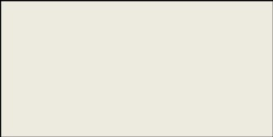

Data

Clustering

04

### 2. Architecture Description

2.1 Data Description

We will be using Thyroid Disease Data Set present in UCI Machine Learning Repository. This Data set is satisfying our data requirement. Total 7200 instances present in different batches of data.

2.2 Export Data from database to CSV for Training

Here we will be exporting all batches of data from database into one csv file for training.

2.3 Data Preprocessing

We will be exploring our data set here and do EDA if required and perform data preprocessing depending on the data set. We first explore our data set in Jupyter Notebook and decide what pre-processing and Validation we have to do such as imputation of null values, dropping some column, etc and then we have to write separate modules according to our analysis, so that we can implement that for training as well as prediction data.

3

2.4 Data Clustering

K-Means algorithm will be used to create clusters in the pre-processed data. The optimum number of clusters is selected by plotting the elbow plot. The idea behind clustering is to implement different algorithms to train data in different clusters. The K-means model is trained over pre-processed data and the model is saved for further use in prediction

2.5 Get best model of each cluster

Here we will train various model on each cluster which we will obtain in Data Clustering, and then will try to get best model of each cluster.

2.6 Hyperparameter Tuning

After selecting best model for each cluster, we will do hyperparameter tuning for each selected model, and try to increase performance of the models.

05

2.7 Model Saving

After performing hyperparameter tuning for models, we will save our models so that we can use them for prediction purpose.

2.8 Cloud Setup

Here We will do cloud setup for model deployment. Here we also create our flask app and user interface and integrate our model with flask app and UI

2.9 Push app to cloud

After doing cloud setup and checking app locally, we will push our app to cloud to start the application.

2.10 Data from client side for prediction purpose

Now our application on cloud is ready for doing prediction. The prediction data which we receive from client side will be exported from DB and further will do same data cleansing process as we have done for training data using modules we will write for training data. Client data will also go along the same process of Exporting data from DB, Data pre-processing, Data clustering and according to each cluster number we will use our saved model for prediction on that cluster.

2.11 Export Prediction to CSV

Finally when we get all the prediction for client data, then our final task is to export prediction to csv file and hand over it to client.

06

3. User Flow

A diagram that shows the path user will take through our web app or website to achieve their goal of predicting thyroid disease.

3.1 Single User UI

We will have a single user UI for our user. Which will be a single page UI. Where user need to follow only these following steps:

1. User need to put all necessary information in the input fields.
2. And then user will have to click on predict button for getting their output.



Web App URL



Fill all Inputs



Click Predict

Button

3.2 Bulk Prediction User Interface

We will also have a User Interface for those user who want to make bulk prediction by using CSV file. This UI will serve their purpose of making batch file prediction. Which will be a single page UI. Where user need to follow only these following steps:

1. User need to upload CSV file for bulk prediction.

1. After uploading CSV file user need to click on prediction button.

1. A new pop up window will open in right side of UI, Where user will find an option to download their result in CSV file.

1. User will also find an option in UI to download sample file for bulk prediction. Which will give user an idea for making data collection for making bulk prediction.

07



User

Flow

For

Bulk

Prediction

UI



Upload

CSV

File

For

Prediction



Click on Predict Button



Web App URL

### Download Result in CSV file Format

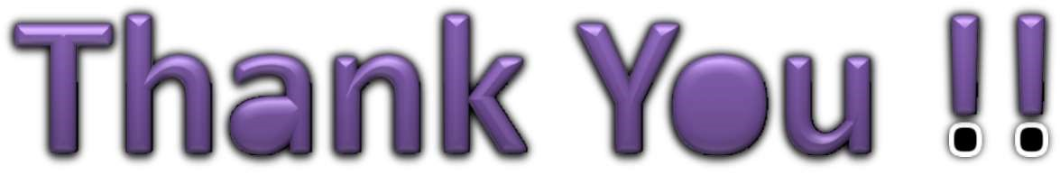

08